REGISTRATION FORM

COMPETITION GROUP

2017/2018
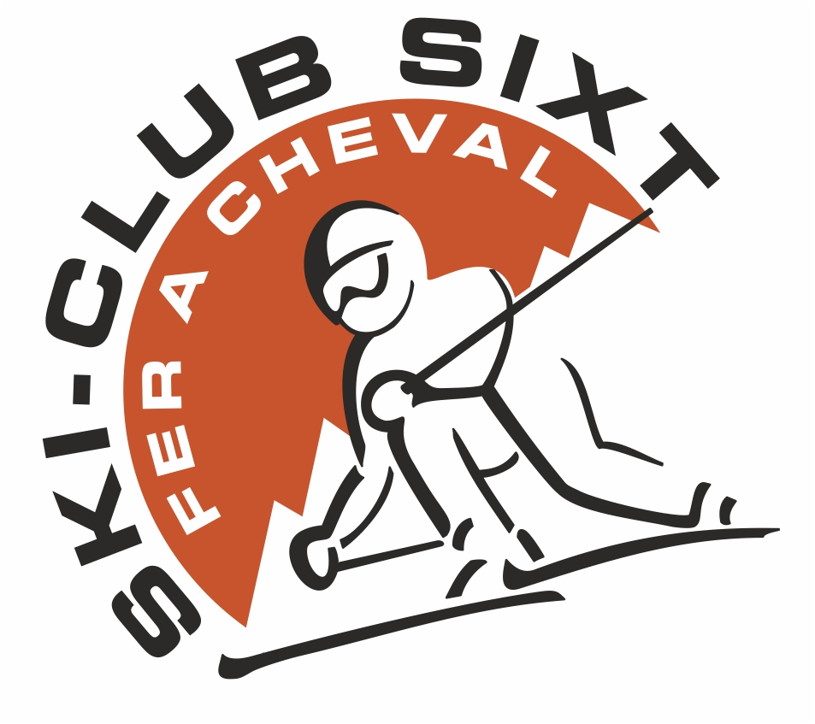
Information relating to the member

- SURNAME : ........................................................... FIRST NAME.........................................................
- DATE OF BIRTH : ....................................... PLACE OF BIRTH : .........................................
- ADDRESS : ............................................................. POSTCODE : .......... TOWN : ..........................................
- NAME AND SURNAME OF PARENTS : ............................................................................................................
- HOME PHONE : ..................................................... EMAIL ADDRESS : ................................................
- FATHER’S MOBILE : ........................................... MOTHER’S MOBILE : ..................................

Transport authorisation

I, undersigned Mr / Mrs, .............................................................................................................., as mother / father and legal representative of .....................................................................................,
Authorize my child to be driven in a vehicle in the context of the activities of the association, during the winter season 2017-18, in particular for transport to training sessions and competitions.

Parental authorisation : Medical emergency

I, undersigned Mr / Mrs ...................................................................................................................................
Authorise the coach of my child to take all measures necessary in the event of a medical emergency : medical acts or hospitalisation in the closest hospital.

Authorisation : Image rights

In order to be in compliance with French law, we need your authorisation for the image of your child, taken in the context of the activities of the Ski Club, to be published on the Ski Club Facebook account, in the club calendar or on the Ski Club web site.

- I authorise
- I do not authorise

Subscriptions

The legal representatives of the child must pay the subscription fees for the association SKI-CLUB DE SIXT FER-A-CHEVAL for the registration of the child named above in the Competition Group.
The subscription is as follows:

286.90€ (subscription 190 € + license 89.90 € + membership fee 7 €, which includes the ski pass) for the G2 and G3 groups.
311.90€ (subscription 215 € + license 89.90 € + membership fee 7 €, which includes the ski pass) for the G1 group.
338.90€ (subscription 215€ + license 116.90€ + membership 7€, which includes the ski pass for children under 18) for the G1+ (children born in 2002 and before). For adult members, the ski club does not provide ski passes.

Payment method :
• 1 cheque : 286.90€, 311.90€ ou 338.90€ (deposited at the end of December 2017).
• 3 chèques : 95€/95€/96.90€ or 105.9€/103€/103€ or 112.90€/113€/113€ (depositied December 2017, January 2018 and February 2018)

SIXT FER-A-CHEVAL, on ................................................
Signature of the legal representative, preceeded by « Read and approved »

Ski club de Sixt Fer-à-Cheval Le Bourg 74740 Sixt Fer-à-Cheval, skiclub.sixt@orange.fr

